***Hardware Exploration of Collab***

GPU: 1xTesla K80

NVIDIA Tesla K80 words most powerful GPU--The NVIDIA® Tesla® K80 Accelerator dramatically lowers data center costs by delivering exceptional performance with fewer, more powerful servers.

compute 3.7,

having 2496 CUDA cores - CUDA cores are an Nvidia GPU’s equivalent of CPU cores. They are optimized for running a large number of calculations simultaneously, something that is vital for modern graphics.

12GB GDDR5 VRAM

CPU: 1xsingle core hyper threaded Xeon Processors @2.3Ghz i.e(1 core, 2 threads)

RAM: ~12.6 GB Available

Disk: ~33 GB Available

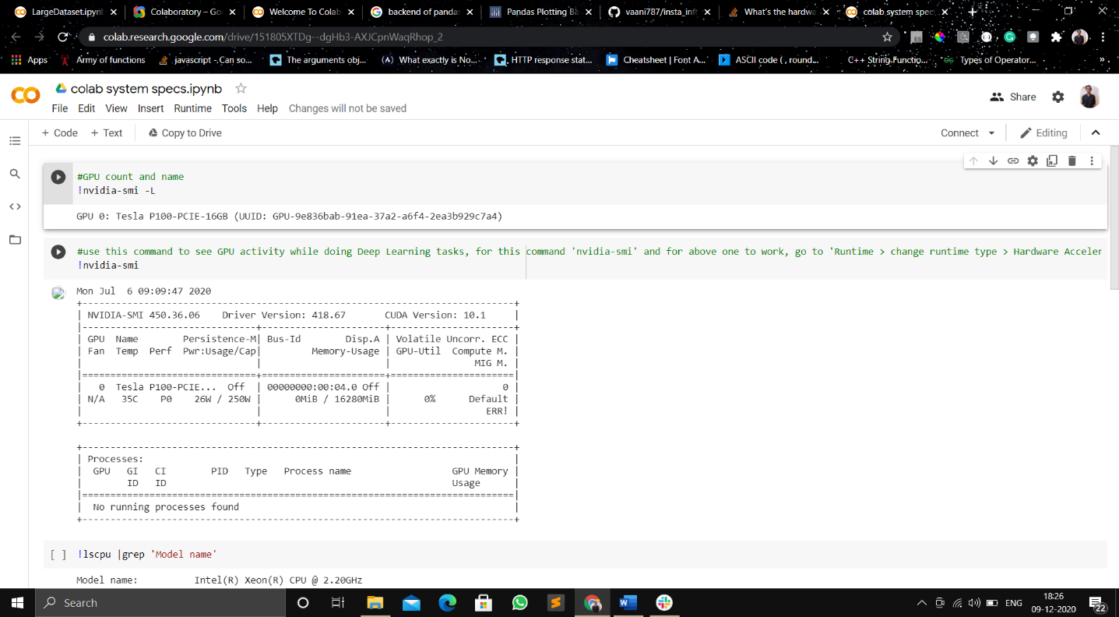

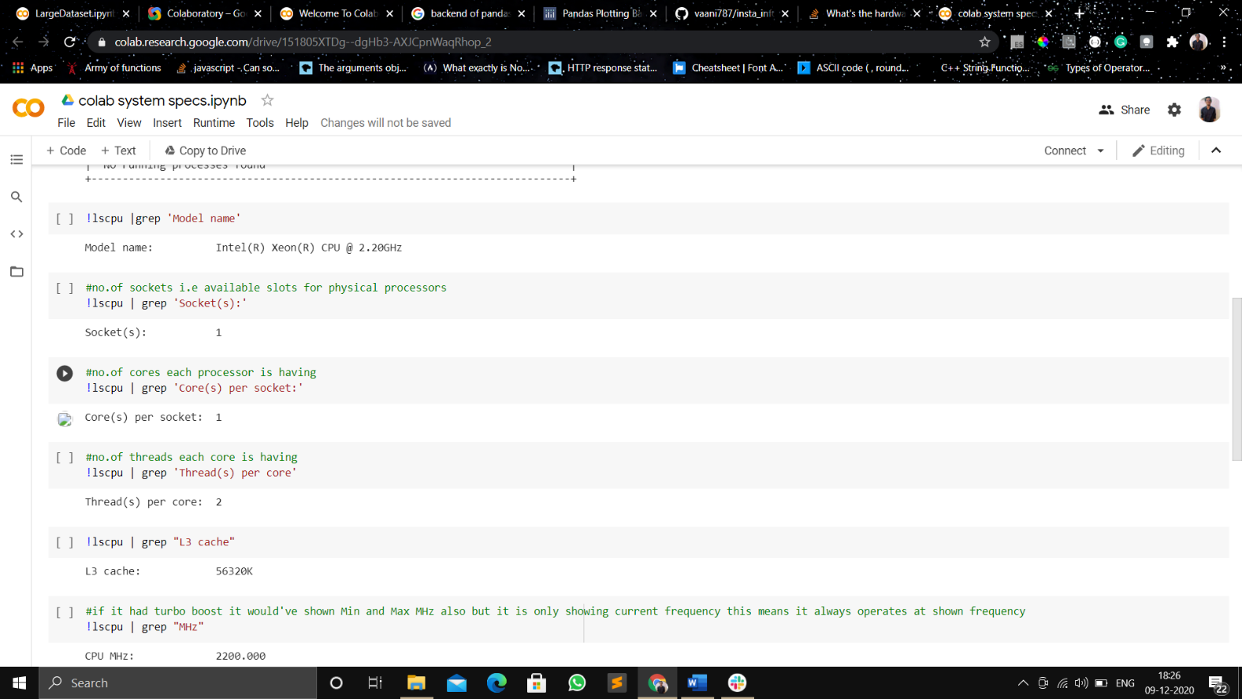

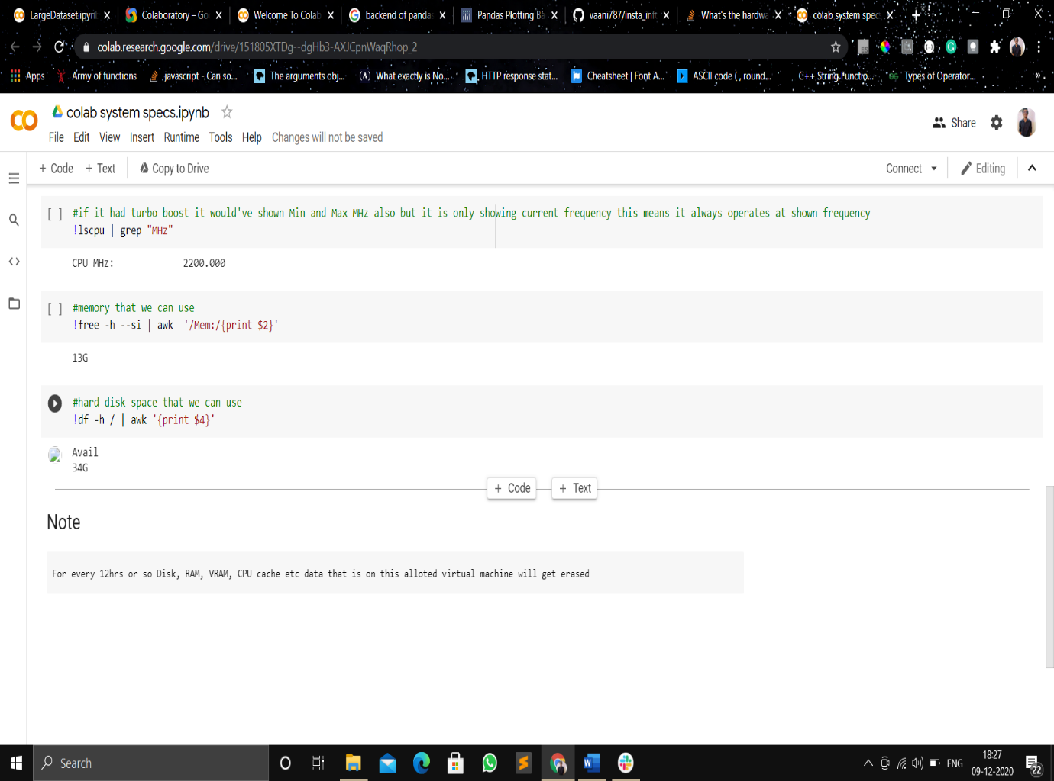

Link : <https://colab.research.google.com/drive/151805XTDg--dgHb3-AXJCpnWaqRhop_2>

**What types of GPUs are available in Colab?**

The types of GPUs that are available in Colab vary over time. This is necessary for Colab to be able to provide access to these resources for free. The GPUs available in Colab often include Nvidia K80s, T4s, P4s and P100s. There is no way to choose what type of GPU you can connect to in Colab at any given time. Users who are interested in more reliable access to Colab’s fastest GPUs may be interested in [Colab Pro](http://colab.research.google.com/signup?utm_source=faq&utm_medium=link&utm_campaign=what_types_of_gpus).

**Google Colab Pro**

Google recently introduced **Colab Pro**, which provides faster GPUs, longer runtimes, and more memory. ... It enables faster training with improved GPUs, and also provides longer runtimes that can reduce disconnection

**How much memory is available in Colab?**

The amount of memory available in Colab virtual machines varies over time (but is stable for the lifetime of the VM). (Adjusting memory over time allows us to continue to offer Colab for free.) You may sometimes be automatically assigned a VM with extra memory when Colab detects that you are likely to need it. Users interested in having more memory available to them in Colab, and more reliably, may be interested in [Colab Pro](http://colab.research.google.com/signup).

Note that using Colab for cryptocurrency mining is disallowed entirely, and may result in your account being restricted for use with Colab altogether.